OPERATION MANUAL OF MHSF FOR
BAU

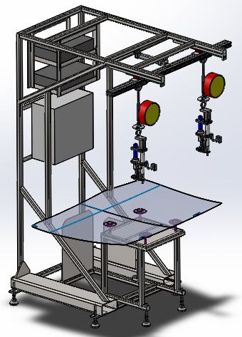

 | CONTENTS
1 | EQUIPMENT SPECIFICATION SHEET
2 | GENERAL LAYOUT
3 | GENERAL ASSEMBLY DRAWING
4 | PARTS DRAWING
5 | MACHINE OPERATION
6 | SPARE PARTS LIST
7 | PNEUMATIC PIPING DIAGRAM
8 | ELECTRICAL DRAWINGS
9 | ELECTRICAL PROGRAM & PARAMETER BACK UP

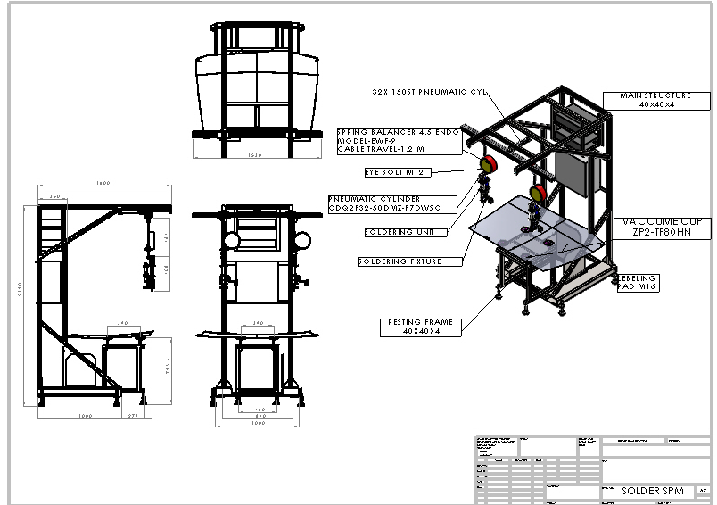
Machine Layout With BOM

Fixture Assembly With BOM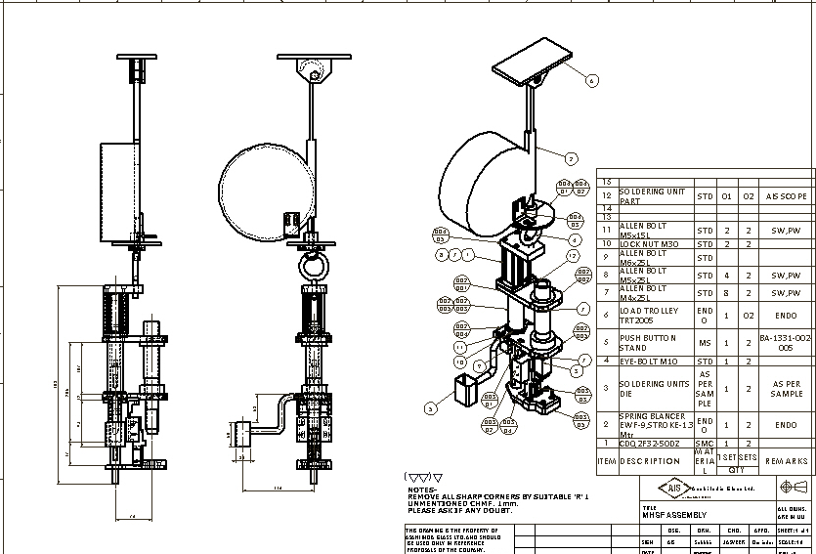

Wear And Tear Parts
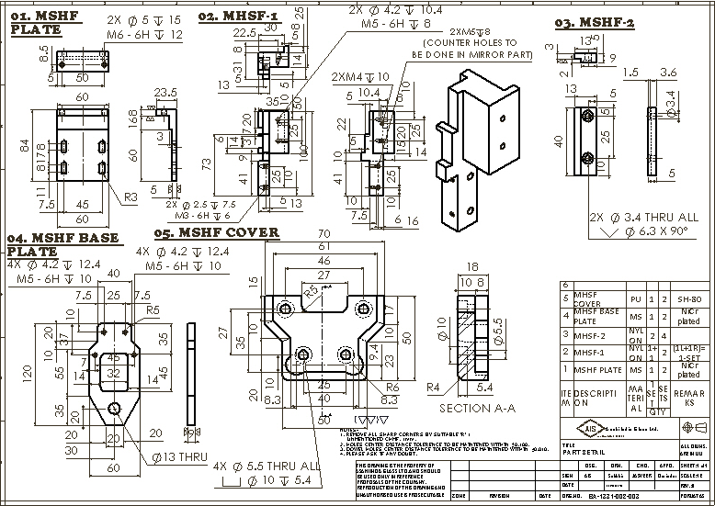
MECHANICAL BOM
Description | Spec. | Make | Qty.
PRESSURE RELIEF VALVE | VHS400-03-X1 | SMC | 1
FRL, 3/8" RC WITH GAUGE | AC30A-03G1-A | SMC | 1
PR.SWITCH | IS3000-02L5 | SMC | 1
SOLENOID VALVE ASSY | VV714-X9S1026 | SMC | 1
SOLENOID VALVE | VQ7-6-FG-D-3Z | SMC | 2
VACCUM EJECTOR | ZH10DS-06-06-08 | SMC | 4
SILENCER | AN15-C08 | SMC | 5
COMPACT CYLINDER | CDQ2F32-50DMZ-M9BL | SMC | 2
SPEED CONTROLLER | AS2201F-01-06SA | SMC | 5
SHUTTLE VALVE | VR1220-02 | SMC | 2
SPEED CONTROLLER | AS1201F-M5-06A | SMC | 5
Union Tee | KQ2T06-00A | SMC | 10
FITTING | KQ2T08-00A | SMC | 10
TUBE ROLL 20MTR | TU0604BU-20 | SMC | 2
TUBE ROLL | TU0805BU-20 | SMC | 2
VACUUM PAD | ZPT80HN-A16 | SMC | 4
AIR CYLINDER | MDBL32-200Z-M9BL | SMC | 1
Male connector | KQ2H08-01AS | SMC | 10
SILENCER | AN10-01 | SMC | 5
SOLENOID VALVE | SY5120-5DZ-01 | SMC | 1
FLOATING JOINT | JA30-10-125 | SMC | 1
SPEED CONTROLLER | AS2201F-01-08SA | SMC | 5
Endo Runway Rail Alum. SWL-100KG. | TR2000 | ENDO | 1
Load Trolley | TRT2005 | ENDO | 2
Endo Spring Balancer Cap. 4.5~9 Kg. , Stroke 1.3M | EWF-9 | ENDO | 2
LEVELLING PAD | NFJN16-130-SC | MISUMI | 6
LM RAIL (L=350mm.) | HGH15 | HIWIN | 2
LM BLOCK | HGH 15 | HIWIN | 2

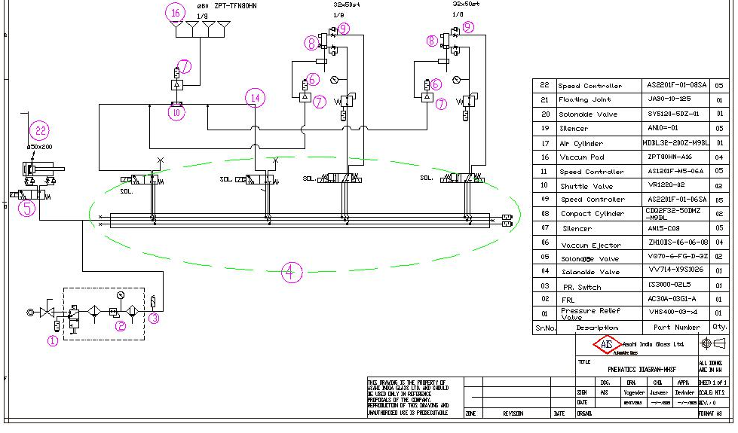

This manual describes procedures and conditions for operating MHSF machine in Auto as well as Manual mode.

Auto Mode
Machine can be operated in Auto Mode by following below mentioned steps.
- Put the machine in Auto Mode by moving the Selector switch (Fig1) with ‘Auto/Manual’ tag on it in Auto Mode.
- Press Auto Start push Button (Fig2). If there are no Alarms, Green LED will be switched on (Fig3).
- Place the Clip to be fixed in the cavity designed for it.
- Put the Glass on main Center table. Pull down LEFT OR RIGHT HOSE pipe as required for Soldering. Upon Pulling down any of those, the table will suck the glass and the frame at the top will move forward.
- Move the clip-hose arrangement towards the area of the glass where the Clip has to be fixed.
- Make sure the Glass presses the sensor (Limit Switch).
- Set the time in timer (Fig4). This is the time for which Soldering process will take place. This has to be set only once for every Job change.
- Press the Push Button to start Soldering process.
- On pressing the push button, Ultrasonic generator will start and will remain on for the time set in the Timer.
- Upon completion of the time set in the timer, Ultrasonic generator will switch off.
- Take the Clip-hose arrangement to its home position until sensed by proxy senor. This will release the vacuum and frame at the top will come back to its home position.
- Take off the Glass from the table and repeat the points 3-12 for the next glass.

Manual Mode
Machine can be operated in manual mode by following below mentioned points.

- Put the machine in Manual Mode by moving the Selector switch(Fig1) with ‘Auto/Manual’ tag on it in Manual Mode
- Place the glass on the table and move the manual vacuum selector (Fig6) in on state. This will suck the glass and move the top frame forward.
- Place the Clip to be fixed in the cavity designed for it.
- Move the clip-hose arrangement towards the area of the glass where the Clip has to be fixed.
- Make Sure Glass touches the sensor (Limit Switch).
- Move the Press Cylinder up by selecting Press cylinder up selector switch (Fig5).
- Press the Push Button to start Ultrasonic heating. It will automatically turn off after the timer completes its time.
- Move the Press Cylinder down by selecting Press cylinder down selector switch.
- Move the clip-hose arrangement back to its home position and turn off the vacuum by selecting off mode of manual vacuum selector switch.

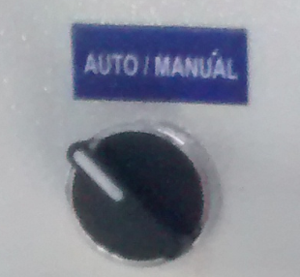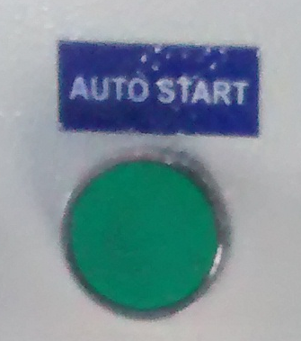
Figure 2 Figure1
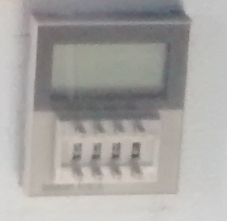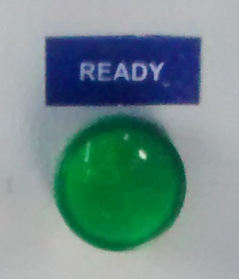
Figure 4 Figure 4
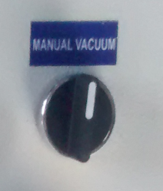 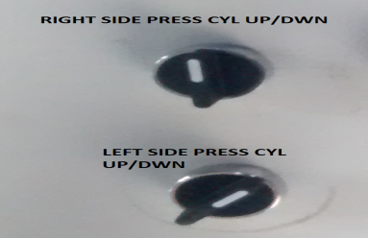 Figure 5 Figure 6
General Overview of Panel:- 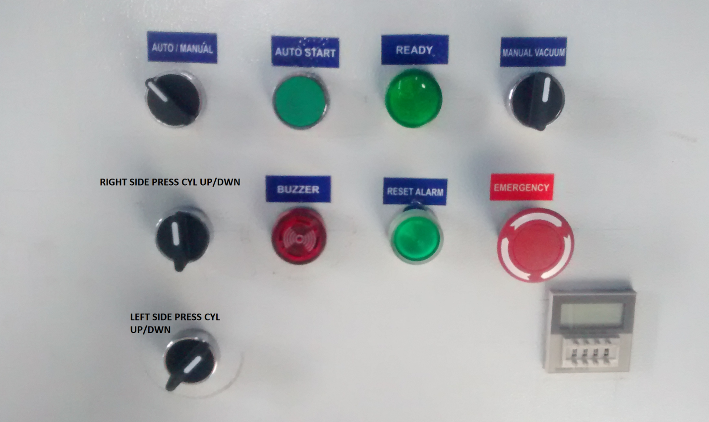

Electrical Bill of material
 | Electrical Bill Of Materials
S.No. | Name of Equipment | No of units
1 | Dukane Generator 4035 LN2 HL1
2 | Dukane Horn 41D28
3 | Dukane cable( generator to horn cable)
4 | Omron CJ2M PLC
5 | Omron OD 212 PLC card
6 | Omron ID 212 PLC card
7 | OMRON SMPS
8 | Siemens two pole circuit breaker (MCB) 6amp
9 | Siemens two pole circuit breaker (MCB)10amp
10 | Siemens two pole circuit breaker (MCB) 20 amp
11 | Emergency Switch
12 | Selector Switch
13 | Buzzer
14 | Green Luminous LED, 24V
15 | Push Button
16 | Omron Timer H3CA
17 | Relays 24 V DC
18 | Proxy switch
19 | Glass photo sensor
20 | Junction Box (500 * 500)

